What’s Next Pine Bluff
Future Center

Leadership Skills
- HAC/TAC
- Conduct in Class/Attitude
- Assignment Schedule
- Note Taking
- Leadership Styles
- Community Service
- Action Plan
Preparing for Careers
- Resume
- Cover Letter
- Letters of Recommendation
- Interview Skills
- Dress Code for Interviews
- Coding
Preparing for the Military
- ASVAB Prep
Preparing for College
- ACT Prep
- Making a College Board Account
- Comparing Colleges on College Board
- Scholarship Essays
- College Applications
- FAFSA
- Paying for College
- College Visit Prep
- Developing References
Leadership Skills
- HAC/TAC
https://hac31.eschoolplus.k12.ar.us/HomeAccess/Account/LogOn?ReturnUrl=%2fhomeaccess%2f

- Conduct in Class/Attitude
Guest Speaker Notes

- Assignment Schedule
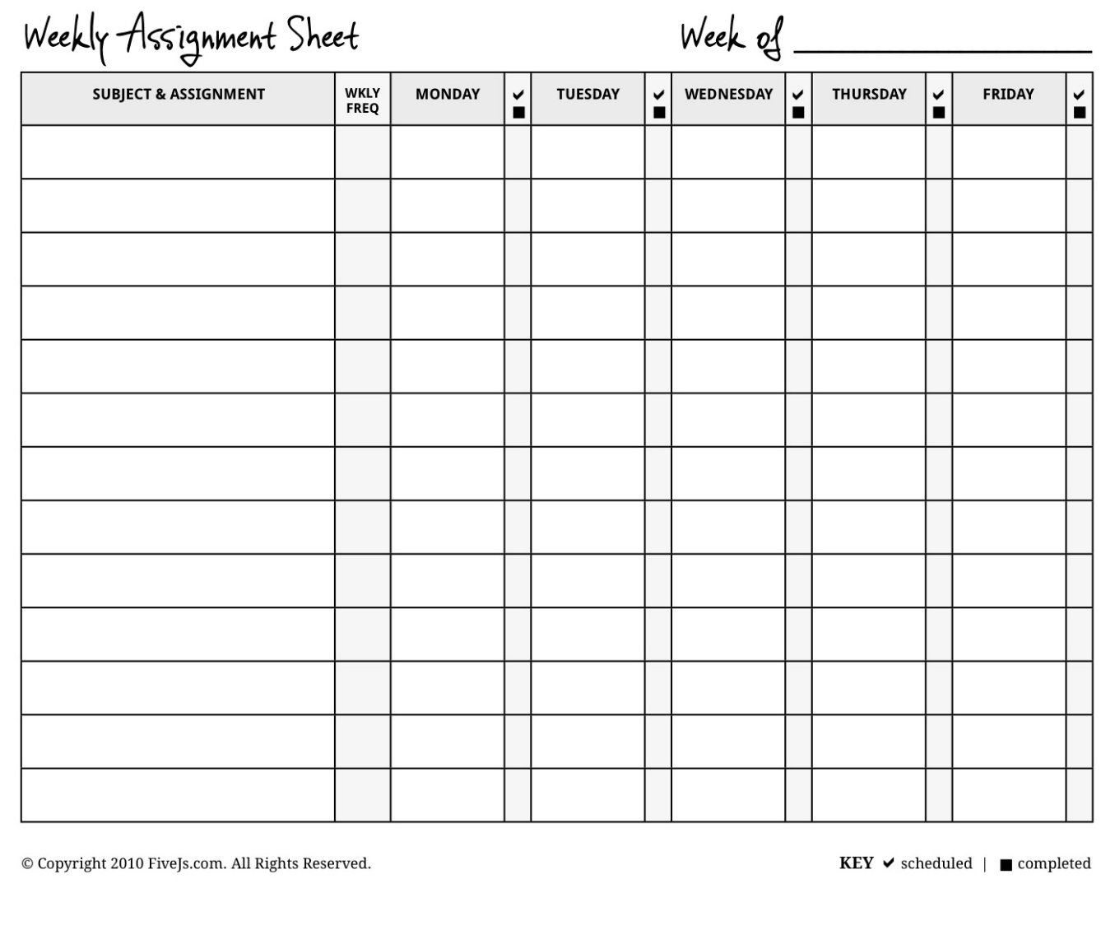

- Make a Google Drive account
Make a Google Account
Go to: https://accounts.google.com/SignUp?continue=https%3A%2F%2Fwww.google.com%2F&hl=en
You will see this screen:
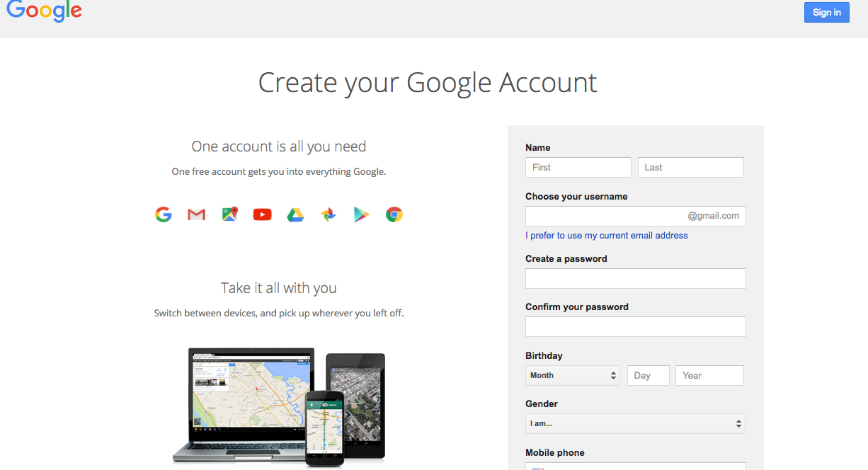

- Fill in your information and make sure to use a username that you would not mind sharing with a potential employer or a college admissions counselor. For example, it is more professional to have the email address tauheed.epps12@gmail.com than 2chainz@gmail.com.

- Once you have a Google Account, you now have a Gmail email account, a Google Drive account, and much more. You can now store documents (for homework, job applications, college applications, resumes, etc.) on this Google Drive account and access them anywhere that you can get the internet.

CORNELL NOTES  SHEET | Name: ________________________________________  Class: ______________________ Topic: ________________________  Date: _______/ _____/ ________  Period ______
QUESTIONS | NOTES
SUMMARY: Write 4 or more sentences describing specific learning from these notes.
__________________________________________________________________________________________
__________________________________________________________________________________________
__________________________________________________________________________________________
__________________________________________________________________________________________
__________________________________________________________________________________________

- Leadership Styles
- Community Service
See a WNPB Facilitator and discuss how community service can fit into your action plan.

- Action Plan
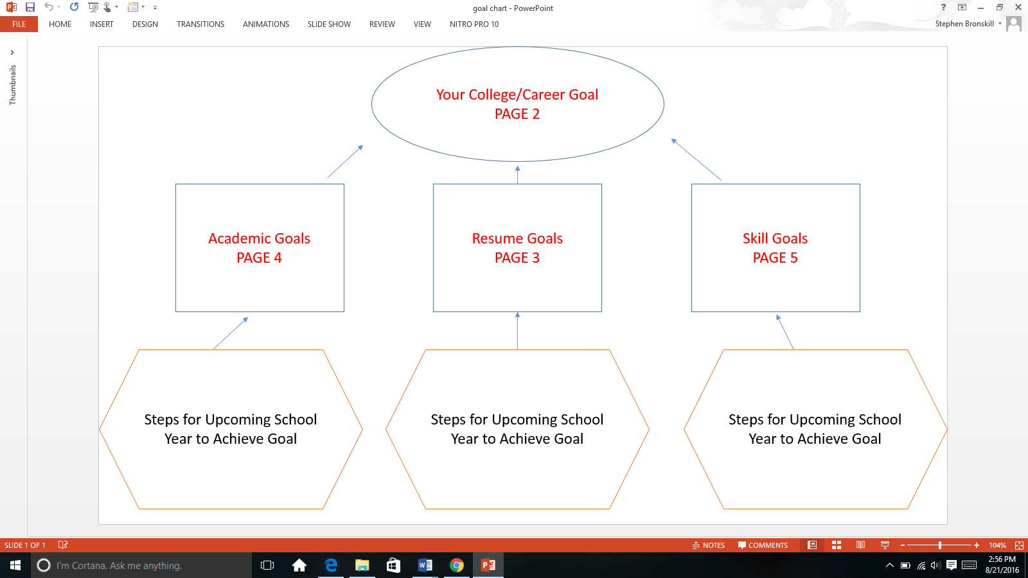

Preparing for Careers
- Resume
MS Word Template or http://www.readwritethink.org/files/resources/interactives/resume_generator/

Resume Tips from the Univ. of Tennessee-Chattanooga :
http://www.utc.edu/career-student-employment/howtowritearesume.ppt
Remember to save on your google drive!
- Letters of Recommendation
3 Teachers/Mentors/Pastors/Coaches, phone number, email
Important Reminders:
- Make sure to ask teachers/mentors/pastors/coaches for a letter of recommendation way ahead of time, preferably a few months before the deadline.
- Make sure to ask someone who knows you well and who will be able to write or speak about specific skills or strengths that you have
- Make sure to be polite and respectful when asking and reminding your teacher/mentor/pastor/coach to complete and submit the letter before the deadline.
My 3 Letters of Recommendation will come from:
Name | Phone | Email

- Cover Letter
Cover Letter Template

Your Name
Street Address
City, State Zip Code
Phone Number

Date

Individual's Name
Job Title
Name of College/Organization
Street Address
City, State Zip Code

Dear Mr./Ms. ________________________________:

First Paragraph: State the reason for writing. Name the specific position or type of work for which you're applying (or college you are hoping to go to). Mention how you learned of the opening/college.

Second Paragraph: Explain why you're interested in working for this employer and specify how you're PERFECT for this position. Don't repeat the information on your resume. Include something special or unique about yourself that will benefit the employer. Remember, the reader will consider this an example of your writing skills.

Third Paragraph: Mention that your resume is enclosed and indicate your desire to meet with the employer/admissions counselor. You may want to suggest alternate dates and times, or simply advise them of your flexibility to the time and place. Include day and evening contact information. Include a statement or question that will encourage the reader to respond. Be sure to communicate your plan to follow up. You might state that you'll be in the area on a certain date and would like to set up a meeting, or you'll call on a certain date to set up a meeting. Finally, thank the employer/admissions counselor for his/her time.
Sincerely,
(Your Signature in blue or black ink)
Your typed name
- Interview Skills
http://changingminds.org/disciplines/job-finding/interview_questions/interview_worksheet.htm
http://empowermentthroughopportunity.com/RCT%20interview%20worksheet..pdf
http://www.jjc.edu/career-services/Documents/interview-questions-worksheet.pdf

- Dress Code for Interviews
http://careernetwork.msu.edu/jobs-internships/appearance-and-attire/dressing-for-interviews.html

- Coding
https://code.org/learn
https://blockly-games.appspot.com/
Preparing for the Military
- ASVAB Prep
https://www.kaptest.com/pages/booksonline
Get the password from WNPB staff
- http://official-asvab.com/samples_app.htm
- http://www.asvabpracticetests.com/
- Find your career fit: http://www.goarmy.com/careers-and-jobs/help-choosing-a-career-job/by-skills-and-interests.html
Preparing for College
- ACT Prep
Register here: http://www.act.org/content/act/en/register.html
Practice
- http://www.act.org/content/act/en/products-and-services/the-act/test-preparation/english-practice-test-questions.html?page=0&chapter=0
- https://www.powerscore.com/sat/help/content_practice_tests.cfm
- Finding a College Fit
https://bigfuture.collegeboard.org/college-search
https://www.collegeraptor.com/Scenario/StartCollegeSearch

- Making a College Board Account
https://bigfuture.collegeboard.org/

- Comparing Colleges on College Board
https://bigfuture.collegeboard.org/compare-colleges
- Scholarship Essays
http://www.arcf.org/Students/StudentsOverview.aspx
http://scholarships.adhe.edu/scholarships-and-programs/a-z/
http://scholarships.adhe.edu/scholarships-and-programs/high-school/
- College Applications
http://www.commonapp.org/
- FAFSA
Sign up for a FAFSA Workshop with WNPB!
Make your account here: https://fafsa.gov/

- Paying for College
http://www.consumerfinance.gov/paying-for-college/
- College Visit Prep
https://secure-media.collegeboard.org/CollegePlanning/media/pdf/campus-visit-checklist.pdf

- Budgeting Activity
See WNPB Staff

